Lab 08 – Arhaan Girdhar
Web Programming Lab

Q1. Develop a web application using Django framework to demonstrate the transfer of
multiple parameters between web pages. User should be presented with a dropdown
list containing car manufacturers, a text box which takes model name of the
manufacturer and a submit button. On submitting the web page, the user is forwarded
to a new page. This new page should display the selected car manufacturer name and
the model name.

Forms.py

from django import forms

class CarForm(forms.Form):
manufacturer = forms.ChoiceField(
choices=[
('Toyota', 'Toyota'),
('Honda', 'Honda'),
('Ford', 'Ford'),
('BMW', 'BMW'),
('Audi', 'Audi')
],
label="Car Manufacturer",
widget=forms.Select(attrs={'class': 'form-select'})
)
model = forms.CharField(
max_length=100,
label="Model Name",
widget=forms.TextInput(attrs={'class': 'form-control'})
)

Views.py

from django.shortcuts import render
from .forms import CarForm

def index(request):
form = CarForm(request.POST or None)
if request.method == 'POST' and form.is_valid():
manufacturer = form.cleaned_data['manufacturer']
model = form.cleaned_data['model']
context = {'manufacturer': manufacturer, 'model': model}
return render(request, 'car_app/result.html', context)
return render(request, 'car_app/index.html', {'form': form})

Urls.py

from django.contrib import admin
from django.urls import path, include

urlpatterns = [
path('admin/', admin.site.urls),
path('', include('car_app.urls')),
]

Apps.py

from django.apps import AppConfig

class CarAppConfig(AppConfig):
default_auto_field = 'django.db.models.BigAutoField'
name = 'car_app'

Index.html

<!DOCTYPE html>
<html lang="en">
<head>
<meta charset="UTF-8">
<title>Car Selection</title>
<meta name="viewport" content="width=device-width, initial-scale=1.0">
<link href="https://cdn.jsdelivr.net/npm/bootstrap@5.3.0/dist/css/bootstrap.min.css" rel="stylesheet">
<link rel="stylesheet" href="/static/css/style.css">
</head>
<body class="bg-dark text-light">
<div class="container py-5">
<div class="card bg-secondary mb-3 shadow-lg">
<div class="card-header text-center">
<h1>Select Car Manufacturer and Model</h1>
</div>
<div class="card-body">
<form method="post">
{% csrf_token %}
<div class="mb-3">
{{ form.manufacturer.label_tag }}
{{ form.manufacturer }}
</div>
<div class="mb-3">
{{ form.model.label_tag }}
{{ form.model }}
</div>
<div class="text-center">
<button type="submit" class="btn btn-primary">Submit</button>
</div>
</form>
</div>
</div>
</div>
<script src="https://cdn.jsdelivr.net/npm/bootstrap@5.3.0/dist/js/bootstrap.bundle.min.js"></script>
</body>
</html>

Result.html

<!DOCTYPE html>
<html lang="en">
<head>
<meta charset="UTF-8">
<title>Car Details</title>
<meta name="viewport" content="width=device-width, initial-scale=1.0">
<link href="https://cdn.jsdelivr.net/npm/bootstrap@5.3.0/dist/css/bootstrap.min.css" rel="stylesheet">
<link rel="stylesheet" href="/static/css/style.css">
</head>
<body class="bg-dark text-light">
<div class="container py-5">
<div class="card bg-secondary mb-3 shadow-lg">
<div class="card-header text-center">
<h1>Selected Car Details</h1>
</div>
<div class="card-body">
<p><strong>Manufacturer:</strong> {{ manufacturer }}</p>
<p><strong>Model Name:</strong> {{ model }}</p>
<div class="text-center">
<a href="/" class="btn btn-outline-light">Back to Form</a>
</div>
</div>
</div>
</div>
<script src="https://cdn.jsdelivr.net/npm/bootstrap@5.3.0/dist/js/bootstrap.bundle.min.js"></script>
</body>
</html>

Output

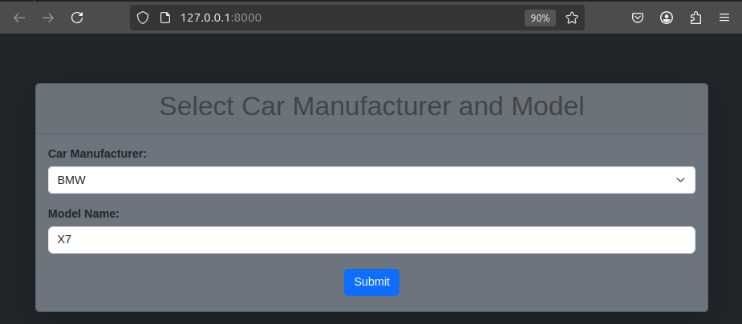

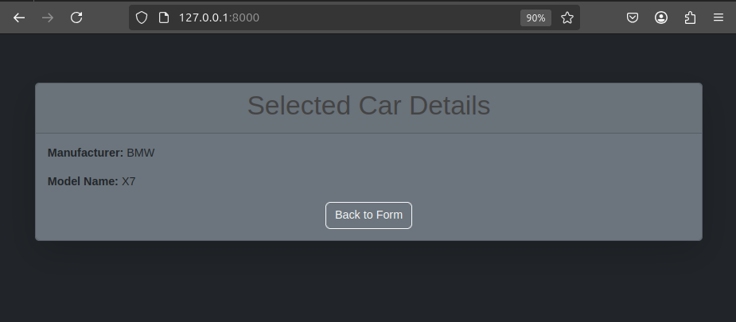

Q2. Create a page firstPage.html with two TextBoxes [Name, Roll], DropDownList
[Subjects], and a button. Create another page secondPage.html with a label and a
button. When the user clicks the button in first Page, he should be sent to the second
page and display the contents passed from first page in the label. The button in second
page should navigate the user back to firstPage. Use Django sessions to transfer
information.

Forms.py

from django import forms

class StudentForm(forms.Form):
model = forms.CharField(
max_length=100,
label="Name",
widget=forms.TextInput(attrs={'class': 'form-control'})
)
model = forms.IntField(
max_length=100,
label="Roll No",
widget=forms.TextInput(attrs={'class': 'form-control'})
)

Views.py

from django.shortcuts import render, redirect

def first_page(request):
if request.method == 'POST':
name = request.POST.get('name')
roll = request.POST.get('roll')
subject = request.POST.get('subject')
request.session['name'] = name
request.session['roll'] = roll
request.session['subject'] = subject
return redirect('second_page')
return render(request, 'session_app/firstPage.html')

def second_page(request):
name = request.session.get('name', 'N/A')
roll = request.session.get('roll', 'N/A')
subject = request.session.get('subject', 'N/A')
context = {
'name': name,
'roll': roll,
'subject': subject,
}
return render(request, 'session_app/secondPage.html', context)

Urls.py

from django.urls import path
from . import views

urlpatterns = [
path('', views.first_page, name='first_page'),
path('second/', views.second_page, name='second_page'),

]

Apps.py

from django.apps import AppConfig

class SessionAppConfig(AppConfig):
default_auto_field = 'django.db.models.BigAutoField'
name = 'session_app'

Index.html

<!DOCTYPE html>
<html lang="en">
<head>
<meta charset="UTF-8">
<title>First Page</title>
<link rel="stylesheet" href="/static/css/style.css">
</head>
<body>
<h1>Enter Your Details</h1>
<form method="post">
{% csrf_token %}
<label for="name">Name:</label>
<input type="text" id="name" name="name" required>
<br><br>
<label for="roll">Roll:</label>
<input type="text" id="roll" name="roll" required>
<br><br>
<label for="subject">Subject:</label>
<select id="subject" name="subject">
<option value="Maths">Maths</option>
<option value="Physics">Physics</option>
<option value="Chemistry">Chemistry</option>
<option value="Biology">Biology</option>
</select>
<br><br>
<button type="submit">Submit</button>
</form>
</body>
</html>

Result.html

<!DOCTYPE html>
<html lang="en">
<head>
<meta charset="UTF-8">
<title>Second Page</title>
<link rel="stylesheet" href="/static/css/style.css">
</head>
<body>
<h1>Received Information</h1>
<p id="info">
<strong>Name:</strong> {{ name }}<br>
<strong>Roll:</strong> {{ roll }}<br>
<strong>Subject:</strong> {{ subject }}
</p>
<form action="{% url 'first_page' %}" method="get">
<button type="submit">Back to First Page</button>
</form>
</body>
</html>

Output

